DELPHIX 1.0.8

Main changes between original version DelphiX2000_0717-2 and unofficial DelphiX.

Installation
Installation is easy now; you can use our installation program. Original package support Delphi 3, 4 and 5 only, there are included all higher version of Delphi.
Installation step by step
1/ Welcome page (under main screen is little help hint pane –activation click to help line)
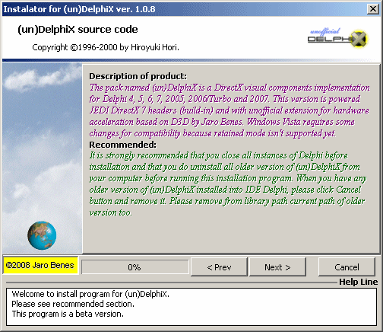
2/ Panel “About” with the update functionality (direct check our site for give newest version of the installator can be checked from there).
About panel is invoked when you click to my copyright in yellow box.
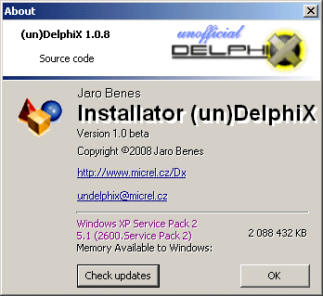
2/ Agreement page
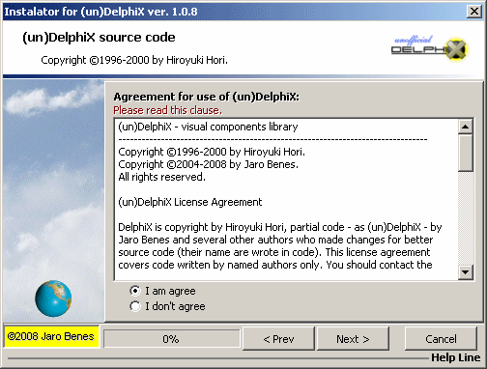
3/ Check installation type by destination of sources
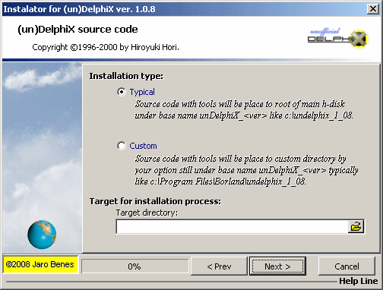
4/You choose compiler of Delphi (must be correct with all paths). When you don’t want install to IDE because you prefer manual installation, tick the box named “Don’t start compilation, copy files only.”
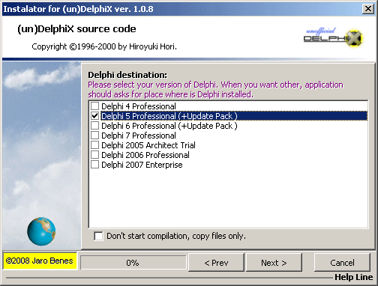
5/ Information before installation. Process installation/copying will be start click to button “Install”.
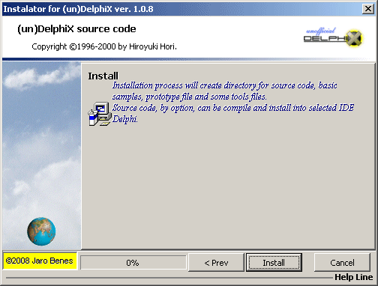
6/ Résumé panel – all messages from the installator or the compiler are bringing up to resume box and show. Installation will be finished click to “Finish” button.
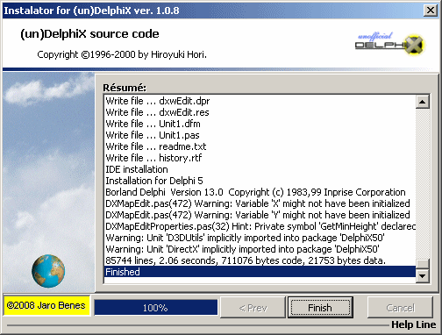

Note: Installation for Delphi 3 is not any longer supported now, because Delphi 3 unsupported dynamic array, overloading and missing there some new components like TAction. But for hard user of Delphi 3 I have a bit better message, source was ported to Delphi 3 but without some enhancements and main forms was corrected to Delphi 3 loading. Sorry, but it was testing shortly only.

Note: When you don’t want auto installation to IDE Delphi, you can install it manually. For users Delphi 6 and above you can use structured package unit named DelphiX.dpk, there in is build in support for library suffix (but file *.dcp has to compiled into source directory – there can be name conflict when common BDS directory is used) depend version of Delphi.

Unit DIB

New type for resample, disorting and support for adopted library conFussion Effects.

type
TFilterTypeResample = (ftrBox, ftrTriangle, ftrHermite, ftrBell, ftrBSpline, ftrLanczos3, ftrMitchell);
TDistortType = (dtFast, dtSlow);
{DXFusion effect type}
TFilterMode = (fmNormal, fmMix50, fmMix25, fmMix75);
TLightSource = record
X, Y: Integer;
Size1, Size2: Integer;
Color: TColor;
end;
TLightArray = array of TLightsource;
TMatrixSetting = array [0..9] of Integer;

New special functions for alpha channel support in DIB32:

function HasAlphaChannel: Boolean;
function AssignAlphaChannel(ALPHA: TDIB; ForceResize: Boolean): Boolean;
procedure RetAlphaChannel(out DIB: TDIB);

Example:

var dib, alpha, mask: TDIB;

dib := TDIB.Create;
alpha := TDIB.Create;
try
alpha.Assign(imgMask.Picture.Bitmap); // contain 8 bit alpha mask
dib.Assign(imgPict.Picture.Bitmap); // contain 24 bit image
dib.AssignAlphaChannel(alpha); // add mask to picture and recreate DIB32
if dib.HasAlphaChannel then // test that image contain alphachannel
dib.RetAlphaChannel(mask); // get it as special image

//next using of dib image is there
finally
alpha.Free; //freeing
dib.Free;
end;

New functions and procedures TDIB

When function or procedure used is, usually are image context changes. When is not explicit wrote, the amount is used for effect specification or quantification. When is supported bit count other of 24 bit, it is marked.

Effect spray is used for specific amount:
procedure Spray(Amount: Integer);
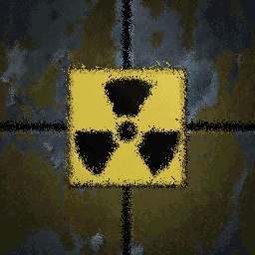
Effect emboss recount image and embossing edges.
procedure Emboss;
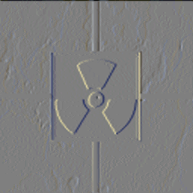
Effect is similar as spray, added a monochromatic noise (support 24, 8 and 4 bit DIB):
procedure AddMonoNoise(Amount: Integer);

Effect is similar as AddMonoNoise but added gradient yet (support 24, 8 and 4 bit DIB):
procedure AddGradiantNoise(Amount: Byte);
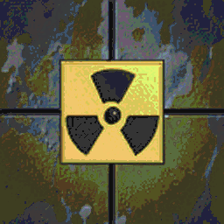
Effect does twist of added image:
function Twist(bmp: TDIB; Amount: Byte): Boolean;
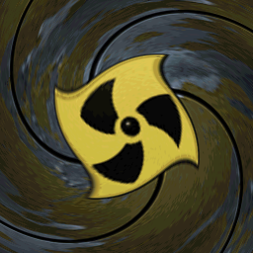
Effect does simple fish eye look:
function FishEye(bmp: TDIB): Boolean;
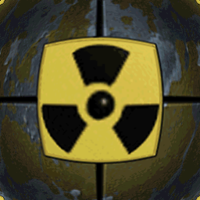
Effect does smooth rotate about specific coordinates with explicit degree and tiled:
function SmoothRotateWrap(Bmp: TDIB; cX, cY: Integer; Degree: Extended): Boolean;
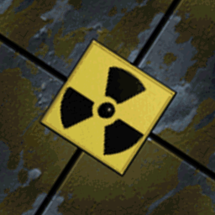
Effect does lighting image:
procedure Lightness(Amount: Integer);
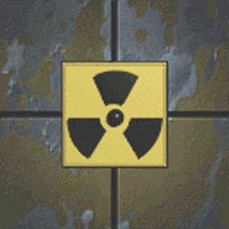
Effect does saturation image:
procedure Saturation(Amount: Integer);
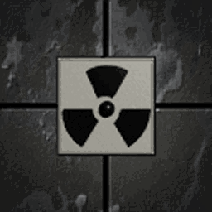
Effect does detail contrast of image:
procedure Contrast(Amount: Integer);

Effect adding specific color as R G B representation to color table:
procedure AddRGB(aR, aG, aB: Byte);
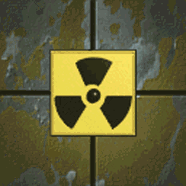
Effect support filtering for 24 an 8 bit DIB:
function Filter(Dest: TDIB; Filter: TFilter): Boolean;
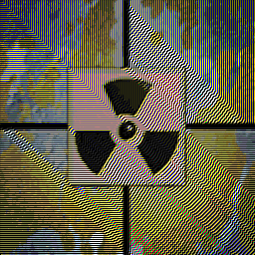
Effect does sharping edges of image:
procedure Sharpen(Amount: Integer);
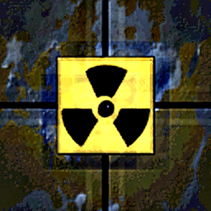
Helpers function for convert integer to B G R format:
function IntToColor(i: Integer): TBGR;
Simple rotate image (support 24, 8, 4, 1 bit DIB only):
function Rotate(Dst: TDIB; cX, cY: Integer; Angle: Double): Boolean;

Effect does splitting blur on image:
procedure SplitBlur(Amount: Integer);
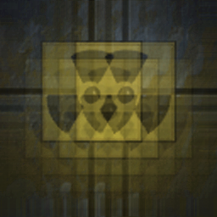
Effect does application Gaussian blur on image:
procedure GaussianBlur(Bmp: TDIB; Amount: Integer);

Next are special functions from confusion library. Some functions do identical work like as previous overwritten.

Following functions do many effects on image:
procedure DoInvert;
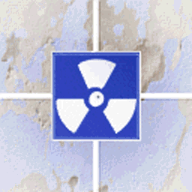
procedure DoAddColorNoise(Amount: Integer);
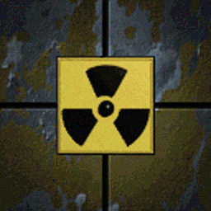
procedure DoAddMonoNoise(Amount: Integer);

procedure DoAntiAlias;

procedure DoContrast(Amount: Integer);

procedure DoFishEye(Amount: Integer);

procedure DoGrayScale;
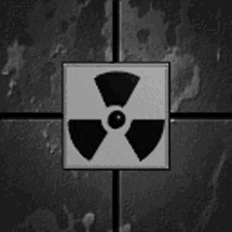
procedure DoLightness(Amount: Integer);

procedure DoDarkness(Amount: Integer);

procedure DoSaturation(Amount: Integer);
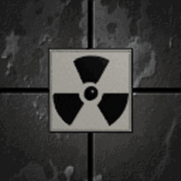
procedure DoSplitBlur(Amount: Integer);
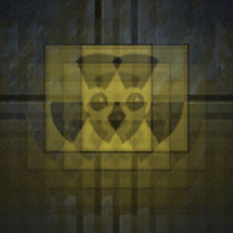
procedure DoGaussianBlur(Amount: Integer);

procedure DoMosaic(Size: Integer);
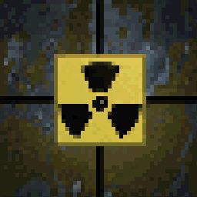
procedure DoTwist(Amount: Integer);
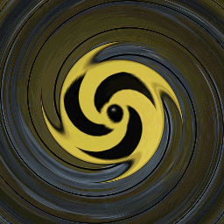
procedure DoSplitlight(Amount: Integer);
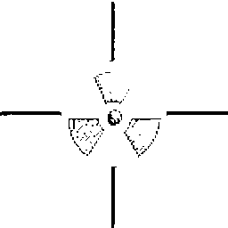
Simple tilling image
procedure DoTile(Amount: Integer);
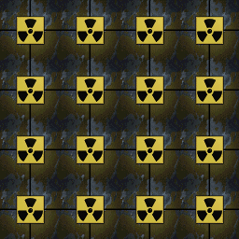
Effect shows spot light on specified place (Amount is image darkness and Spot is rectangle for circle/ellipse):
procedure DoSpotLight(Amount: Integer; Spot: TRect);
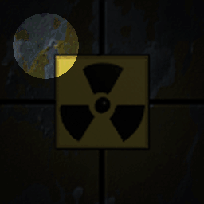
procedure DoTrace(Amount: Integer);
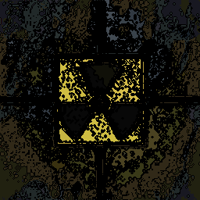
procedure DoEmboss;
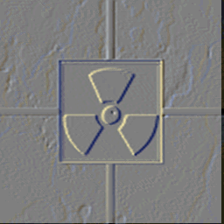
procedure DoSolorize(Amount: Integer);
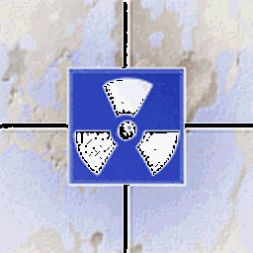
procedure DoPosterize(Amount: Integer);

procedure DoColorize(ForeColor, BackColor: TColor);

procedure DoBrightness(Amount: integer);
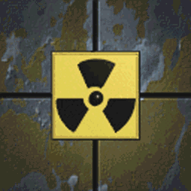
Effect for resizing image layer with using sophisticated resample filters, very useable:
procedure DoResample(AmountX, AmountY: integer; TypeResample: TFilterTypeResample);

Another version of smooth rotate, very useable:
procedure DoSmoothRotate(Src: TDIB; cx, cy: Integer; Angle: Extended);
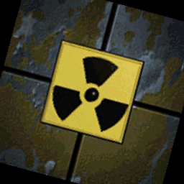

Simple explosion spoke effect, can be masked. It is complex function for generate images. When you can use it please see how to use to component editor source named DXDIBEffectEdit:
procedure DoNovaEffect(sr, sg, sb, cx, cy, radius, nspokes, randomhue, randomspok, randgauss: Integer; onProgress: TProgressEvent);
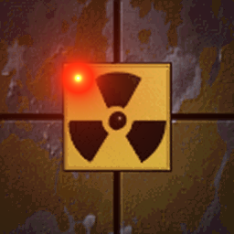
Simple Mandelbrot-set drawing, nothing more:
procedure DrawMandelbrot(ao, au: Integer; bo, bu: Double);
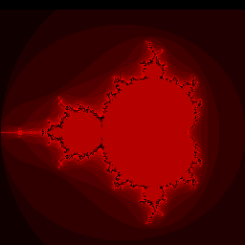
Sephia effect like older photos, initial depth is 20:
procedure SephiaEffect(Depth: Integer);
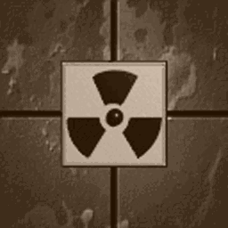
Simple blend pixel:
procedure BlendPixel(const X, Y: Integer; aColor: Cardinal; Alpha: Byte);
Draw line in polar system, parameters are descript able:
procedure LinePolar(x, y: Integer; AngleInDegree, Length: Extended; Color: Cardinal);
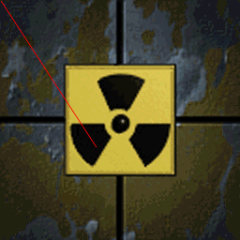
Special version Dark/Light procedure, values in percent:
procedure Darker(Percent: Integer);
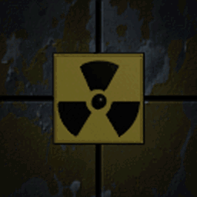
procedure Lighter(Percent: Integer);
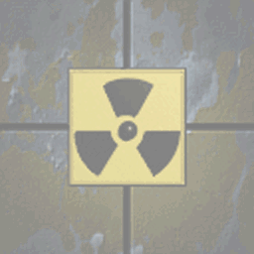
Simple graphical crypting, non graphics function:
procedure EncryptDecrypt(const Key: Integer);
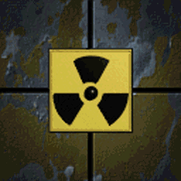 from to and back 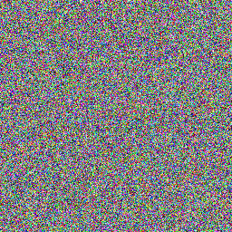
Helpers function for easy create DIB from bitmap:
procedure CreateDIBFromBitmap(const Bitmap: TBitmap);
Analogical function for create bitmap from DIB:
function CreateBitmapFromDIB: TBitmap;
Special versions Draw for drawing to Canvas directly. It is used in following functions:
DrawOn draws own canvas to destination canvas and DrawTo is similar – source DIB draws to own canvas. In real functions are used as replacement similar function from DIBUltra.
procedure DrawOn(Dest: TRect; DestCanvas: TCanvas; Xsrc, Ysrc: Integer);
procedure DrawTo(SrcDIB: TDIB; X, Y, Width, Height, SourceX, SourceY: Integer);

Functions are similar DDS functions like DrawAdd, DrawAlpha or DrawSub, but for DIB surface:
procedure DrawTransparent(SrcDIB: TDIB; const X, Y, Width, Height, SourceX, SourceY: Integer; const Color: TColor);
procedure DrawShadow(SrcDIB: TDIB; X, Y, Width, Height, Frame: Integer; FilterMode: TFilterMode);
procedure DrawDarken(SrcDIB: TDIB; X, Y, Width, Height, Frame: Integer);
procedure DrawAdditive(SrcDIB: TDIB; X, Y, Width, Height: Integer; Alpha: Integer; Frame: Integer);
procedure DrawQuickAlpha(SrcDIB: TDIB; const X, Y, Width, Height, SourceX, SourceY: Integer; const Color: TColor; FilterMode: TFilterMode);
procedure DrawTranslucent(SrcDIB: TDIB; const X, Y, Width, Height, SourceX, SourceY: Integer; const Color: TColor);
procedure DrawMorphed(SrcDIB: TDIB; const X, Y, Width, Height, SourceX, SourceY: Integer; const Color: TColor);
procedure DrawAlpha(SrcDIB: TDIB; const X, Y, Width, Height, SourceX, SourceY, Alpha: Integer; const Color: TColor);
procedure DrawAlphaMask(SrcDIB, MaskDIB: TDIB; const X, Y, Width, Height, SourceX, SourceY: Integer);
Simple antialiasing:
procedure DrawAntialias(SrcDIB: TDIB);
procedure Draw3x3Matrix(SrcDIB: TDIB; Setting: TMatrixSetting);
Draw monochromatic for masks etc.:
procedure DrawMono(SrcDIB: TDIB; const X, Y, Width, Height, SourceX, SourceY: Integer; const TransColor, ForeColor, BackColor: TColor);
One-color Filters:
procedure FilterLine(X1, Y1, X2, Y2: Integer; Color: TColor; FilterMode: TFilterMode);
procedure FilterRect(X, Y, Width, Height: Integer; Color: TColor; FilterMode: TFilterMode);

Lightsource and drawing lights (The light must be defined, it is special part of conFussion library):
procedure InitLight(Count, Detail: Integer);
procedure DrawLights(FLight: TLightArray; AmbientLight: TColor);

Special effect Fade-in and Fade-Out, used only in dynamic buffered drawing or in generation image sequences:
procedure FadeOut(DIB2: TDIB; Step: Byte);
procedure FadeIn(DIB2: TDIB; Step: Byte);
Quick fill 8 bit count DIB:
procedure FillDIB8(Color: Byte);
Helpers function for fill context of DIB (example after creating and size setting):
procedure Fill(aColor: TColor);
Another version of zoom without filter:
procedure DoZoom(DIB2: TDIB; ZoomRatio: Real);
Simple blur;
procedure DoBlur(DIB2: TDIB);
procedure DoRotate(DIB1: TDIB; cX, cY, Angle: Integer);
Special effect of rotating image context:
procedure Distort(DIB1: TDIB; dt: TDistortType; cX, cY, Angle: Integer; Factor: Real);
Special version simulate ink paper:
function Ink(DIB: TDIB; const SprayInit: Boolean; const AmountSpray: Integer): Boolean;
Draw antialiasing line”
procedure AntialiasedLine(x1, y1, x2, y2: Integer; color: TColor);
Draw colored line:
procedure ColoredLine(const iStart, iEnd: TPoint; iColorStyle: TColorLineStyle;
iGradientFrom, iGradientTo: TColor; iPixelGeometry: TColorLinePixelGeometry;
iRadius: WORD);
Helpers function for count color between two colors:
function GetColorBetween(StartColor, EndColor: TColor; Pointvalue, FromPoint, ToPoint: Extended): TColor;

New Property TDIB

Easy access to the alphachannel in DIB. DIB has to declare as DIB 32 always:
property AlphaChannel: TDIB read GetAlphaChannel write SetAlphaChannel;

Easy access to client rectangle
property ClientRect: TRect read GetClientRect;

Unit functions

Function for scale proportionally recount and return scale factor::
function GetScale(SourceWidth, SourceHeight, TargetWidth, TargetHeight: Integer): Single;

Overloaded function for creating empty initialized DIB or bitmap based DIB:
procedure MakeDib(out DIB: TDIB; const iWidth, iHeight, iBitCount: Integer; iFillColor: TColor); overload;
procedure MakeDib (out DIB: TDIB; iBitmap: TBitmap); overload;

Unit DirectX

Unit contains most of interfaces for access to DirectX was completely rebuild and powered JEDI DirectX headers. Some parts of interfaces I have to repair (like part for direct playing MIDI files) or add the missing part.

Unit DXDraws

Basic unit contain all drawing functions DDS based and main block of hardware acceleration.

Unit constant

It can be use only 2048 standalone texture blocks. When is count over, automatically is buffer pruned and texture will be recreated on demand. Buffer can be pruned manually too.
maxTexBlock = 2048; {maximum textures}
One texture has to size limit up to 2048 in width or height. The texture block is defined the square as default always with maximum size 2048 x 2048 px.
maxVideoBlockSize = 2048; {maximum size block of one texture}

Unit types

For basic rendering is defined simple type for better parametring:
TRenderType = (rtDraw, rtBlend, rtAdd, rtSub);

Rendered image can me mirrored or flipped before drawing. Default parameter is nothing.
TRenderMirrorFlip = (rmfMirror, rmfFlip);
TRenderMirrorFlipSet = set of TRenderMirrorFlip;

Enhancements of TDirectDrawSurface

Procedures and functions

Procedure contacts the acceleration module and set mirror or flip before draw operation:
procedure MirrorFlip(Value: TRenderMirrorFlipSet);

Procedures are similar DrawAdd, DrawAlpha or DrawSub but the color parameter is added:
procedure DrawAddCol(const DestRect, SrcRect: TRect; Source: TDirectDrawSurface;
Transparent: Boolean; Color, Alpha: Integer);
procedure DrawAlphaCol(const DestRect, SrcRect: TRect; Source: TDirectDrawSurface;
Transparent: Boolean; Color, Alpha: Integer);
procedure DrawSubCol(const DestRect, SrcRect: TRect; Source: TDirectDrawSurface;
Transparent: Boolean; Color, Alpha: Integer);

Procedure with added the color parameter

procedure DrawRotateAddCol(X, Y, Width, Height: Integer; const SrcRect: TRect; Source: TDirectDrawSurface; CenterX, CenterY: Double; Transparent: Boolean; Angle: Single; Color: Integer; Alpha: Integer);
procedure DrawRotateAlphaCol(X, Y, Width, Height: Integer; const SrcRect: TRect; Source: TDirectDrawSurface; CenterX, CenterY: Double; Transparent: Boolean; Angle: Single; Color: Integer; Alpha: Integer);
procedure DrawRotateCol(X, Y, Width, Height: Integer; const SrcRect: TRect; Source: TDirectDrawSurface; CenterX, CenterY: Double; Transparent: Boolean; Angle: Single; Color: Integer);
procedure DrawRotateSubCol(X, Y, Width, Height: Integer; const SrcRect: TRect; Source: TDirectDrawSurface; CenterX, CenterY: Double; Transparent: Boolean; Angle: Single; Color: Integer; Alpha: Integer);

Drawing waves was enhancement about drawing vertical waves, it is complete new:

procedure DrawWaveY(X, Y, Width, Height: Integer; const SrcRect: TRect; Source: TDirectDrawSurface; Transparent: Boolean; amp, Len, ph: Integer);
procedure DrawWaveYAdd(X, Y, Width, Height: Integer; const SrcRect: TRect; Source: TDirectDrawSurface; Transparent: Boolean; amp, Len, ph: Integer; Alpha: Integer);
procedure DrawWaveYAlpha(X, Y, Width, Height: Integer; const SrcRect: TRect; Source: TDirectDrawSurface; Transparent: Boolean; amp, Len, ph: Integer; Alpha: Integer);
procedure DrawWaveYSub(X, Y, Width, Height: Integer; const SrcRect: TRect; Source: TDirectDrawSurface; Transparent: Boolean; amp, Len, ph: Integer; Alpha: Integer);

Poke function was added for speed drawing (sorry for missing poke-ball):

Simple line drawing for two points:
procedure PokeLine(X1, Y1, X2, Y2: Integer; Color: cardinal);
Drawing line in polar coordinates:
procedure PokeLinePolar(x, y: Integer; angle, length: extended; Color: cardinal);
Simple drawing box:
procedure PokeBox(xs, ys, xd, yd: Integer; Color: cardinal);
Blending pixel:
procedure PokeBlendPixel(const X, Y: Integer; aColor: cardinal; Alpha: byte);
Antialiased line like in Turbopixels:
procedure PokeWuLine(X1, Y1, X2, Y2, aColor: Integer);
Area can be fills any noises:
procedure Noise(Oblast: TRect; Density: Byte);
One line command for standard blur:
procedure Blur;
Rotate surface area like rotate in DIB:
procedure DoRotate(cent1, cent2, angle: Integer; coord1, coord2: Real; color: word);
Fast draw a circle:
procedure PokeCircle(X, Y, Radius, Color: Integer);
Fast draw a ellipse:
procedure PokeEllipse(exc, eyc, ea, eb, angle, color: Integer);
And filled ellipse too:
procedure PokeFilledEllipse(exc, eyc, ea, eb, color: Integer);
Fast draw vertical line for some effects:
procedure PokeVLine(x, y1, y2: Integer; Color: cardinal);

For this was added Alpha factor (as main change), when is accelerated, can be computed to other value and make illusion light or dark glass (initial value is 128):
procedure FillRectAdd(const DestRect: TRect; Color: TColor; Alpha: Byte);
procedure FillRectSub(const DestRect: TRect; Color: TColor; Alpha: Byte);

Properties

It signalized that surface is still locked:
property IsLocked: Boolean read FIsLocked;
It signalized that surface is modified immediately:
property Modified: Boolean read FModified write FModified;

Special version for fast pixel drawing. Surface must be locked when you can use it function
property Pixel[X, Y: Integer]: LongInt read Peek write Poke;

Helper property for identification of surface in texture buffer (I advice to use non anonymous texture for simplest search like videotexture change):
property Caption: TCaption read FCaption write FCaption;

Example:

DXDraw.Surface.Lock; //special version Lock without any parameters
try
DXDraw.Surface.Pixel[X, Y] := TheColor;
TheColor := DXDraw.Surface.Pixel[X + 1, Y + 1];
finally
DXDraw.Surface.Unlock;
end;

Enhancements of TCustomDXDraw

It is heart of classes there.

Procedures and functions

Signal for accelerating subsystem, when is software renderer used it does nothing;
procedure BeginScene;
procedure EndScene;
Signal before draw picture how type of texture filter you want.
procedure TextureFilter(Grade: TD2DTextureFilter);
Copy only. Set the orientation of rendered image
procedure MirrorFlip(Value: TRenderMirrorFlipSet);
Manual prune texture stack. When is used, FPS fall extremely to down.
procedure ClearStack;
Procedure is used in main loop for periodic refresh some videotextures.
procedure UpdateTextures;
Set of procedures can be used for copy from actual surface as screenshot or paste any image (like logo?).
procedure PasteImage(sdib: TDIB; x, y: Integer);
procedure GrabImage(iX, iY, iWidth, iHeight: Integer; ddib: TDIB);
Supplement function for fade based DDS. It is slow and must be called periodically:
function Black2Screen(oldcolor: Integer): Longint;
function Fade2Screen(oldcolor, newcolour: Integer): LongInt;
function White2Screen(oldcolor: Integer): LongInt;
function FadeGrey2Screen(oldcolor, newcolour: LongInt): LongInt;

Properties

There is special property for keeping the trace, like as predefined path in design time for moving any object. It is very complex and be overwritten next passage.
Main purpose is eliminating any hard-coding.
property Traces: TTraces read FTraces write SetTraces;

This event can be used for actualize some textures directly on texture stack. For activate this event must be in main program loop called procedure UpdateTextures.
property OnUpdateTextures: TOnUpdateTextures read FOnUpdateTextures write FOnUpdateTextures;

Example:
Update textures is periodically call in main timer loop. Best place is after flip.
DXDraw.Flip;
//--update afrer flip--
//-in software mode do nothing-
DXDraw.UpdateTextures; //all update can be do there
//---------------------
end;

Main work is in event handler. There can be updated many textures (or image layout), façade of DelphiX is keep.
procedure TForm1.DXDrawUpdateTextures(const Sender: TD2DTextures;
var Changed: Boolean);
var
T: TDIB;
begin
Changed := False;
{can be updated many textures there when it is need}
{search the layout of texture image as DIB}
{texture has to name, it is indispensable for human identify}
{sender is substitute for full texture object used internally}
T := Sender.TexLayoutByName['Blue2'];
{changes image layout}
if Assigned(T) then begin
{context instance T mustn't be lost, image mustn't be recreated}
T.Fill(clBlue); //fill all image by color
//or
T.DrawTo(DXDIB1.DIB,0,0,T.Width,T.Height,0,0); //redraw the image
T.Canvas.Font.Color := clWhite;
T.Canvas.Brush.Style := bsClear;
//draw current date and time demonstrate videotexture
T.Canvas.TextOut(5, 5, DateTimetoStr(Now));
{texture has to updated after changes, it is indispensable!!!}
Sender.GetTextureByName('Blue2').Load;
{and signal to subsystem - any change there}
Changed := True;
end;
end;

This event is activated when is in main program loop call procedure Render(). It is invoked down of drawing all objects as notification event and say only: “rendering is done now”.
property OnRender: TNotifyEvent read FOnRender write FOnRender;

New feature TTraces and TTrace

TTraces is completely new feature, for eliminating any hard-coding when are used moving objects. TTraces is descendant of THashCollection and it keep items of TTrace, and it is descendant THashCollectionItem.
Component is fully integrated into TCustomDXDraw component as own property. Simple tell it is list for Blits only, nothing more.

Procedures and functions

Signal that an item is actualized can be get from there:
function IsActualized: Boolean;
Any item can be assigned from other item with all properties:
procedure Assign(Source: TPersistent); override;
Function allow to clone under new name and with move or rotate offset:
function Clone(NewName: string; OffsetX: Integer = 0; OffsetY: Integer = 0; Angle: Single = 0): Boolean;

Properties

Set activity this item is controlled there:
property Active: Boolean read GetActive write SetActive;
Property is used for general purpose (like any other Tag):
property Tag: Integer read FTag write FTag;
It is main complex object with enhancement functionality:
property Blit: TBlit read FBlit write FBlit;

For one line event handler for initialize image from any DXImageList as external source:
property OnGetImage: TNotifyEvent read GetOnGetImage write SetOnGetImage;
It is invoked when Blit will be moved:
property OnMove: TBlitMoveEvent read GetOnMove write SetOnMove;
It is invoked when Blis is drawing (for drawings are preparing special universal encapsulated functions):
property OnDraw: TNotifyEvent read GetOnDraw write SetOnDraw;
Can be invoked when area of blits is over:
property OnCollision: TNotifyEvent read GetOnCollision write SetOnCollision;
It can be called after rendering. Parameter is the blit object passed as standard sender:
property OnRender: TOnRender read GetOnRender write SetOnRender;

New feature TBlit

TBlit is integral part of Traces and, simple tell, it is main container for path and main effect controller. I want make it simple and all I want it fall into staying architecture of (un)DelphiX.

What is TBlit? It is container for drawing operation and controller.

Properties

Container covered all values and access is through property. You can set all features in windows of Object Inspector.

Signal activity of this Blit:
property Active: Boolean read FActive write FActive default False;
Set that will be controlled overleap:
property Collisioned: Boolean read GetCollisioned write SetCollisioned default True;
Set that will be moved (other will be static image only):
property Moved: Boolean read GetMoved write SetMoved default True;
Set that Blit is visible:
property Visible: Boolean read GetVisible write SetVisible default True;
Coordinates of position in area:
property X: Double read GetX write SetX;
property Y: Double read GetY write SetY;
Can be it signalizing as order of front of.
property Z: Integer read GetZ write SetZ;
Size of images, at first time can be set:
property Width: Integer read GetWidth write SetWidth;
property Height: Integer read GetHeight write SetHeight;
It signalizing that Blit will be move recently:
property MovingRepeatly: Boolean read GetMovingRepeatly write SetMovingRepeatly default True;
It is signalizing that Blit go back in the same way:
property Bustrofedon: Boolean read GetBustrofedon write SetBustrofedon default False;
This properties are adopted from sprite and do the same functionality.
property AnimCount: Integer read GetAnimCount write SetAnimCount default 0;
property AnimLooped: Boolean read GetAnimLooped write SetAnimLooped default False;
property AnimPos: Double read GetAnimPos write SetAnimPos stored StoreAnimPos;
property AnimSpeed: Double read GetAnimSpeed write SetAnimSpeed stored StoreAnimSpeed;
property AnimStart: Integer read GetAnimStart write SetAnimStart default 0;
Blit can be rotated:
property Angle: Single read GetAngle write SetAngle stored StoreAngle;
Blit can be blended, lighted or darkened:
property Alpha: Integer read GetAlpha write SetAlpha default $FF;
Center of rotation
property CenterX: Double read GetCenterX write SetCenterX stored StoreCenterX;
property CenterY: Double read GetCenterY write SetCenterY stored StoreCenterY;
Explicit scale factor (initial value is 1.0):
property Scale: Double read GetScale write SetScale stored StoreScale;
This very important property. There can be change drawinf style.
property BlendMode: TRenderType read GetBlendMode write SetBlendMode default rtDraw;
Blit can be waved, there you can turn on with X o Y direction.
property WaveType: TWaveType read GetWaveType write SetWaveType default wtWaveNone;
There can be use parameters for waving.
property Amplitude: Integer read GetAmplitude write SetAmplitude default 0;
property AmpLength: Integer read GetAmpLength write SetAmpLength default 0;
property Phase: Integer read GetPhase write SetPhase default 0;
Speed is factor added to X or Y coordinate, counted like X := X + SpeedX * LagCount. LagCount is factor for equally speed control.
property SpeedX: Single read GetSpeedX write SetSpeedX stored StoreSpeedX;
property SpeedY: Single read GetSpeedY write SetSpeedY stored StoreSpeedY;
Gravity is special factor added to X or Y coordinate, counted like X := X + GravityX * LagCount. LagCount is factor for equally speed control.
property GravityX: Single read GetGravityX write SetGravityX stored StoreGravityX;
property GravityY: Single read GetGravityY write SetGravityY stored StoreGravityY;
Energy is special factor added to SpeedX and SpeedY, counted like SpeedX := SpeedX + SpeedX * Energy;
property Energy: Single read GetEnergy write SetEnergy stored StoreEnergy;
This is very interesting property. Image can store up to 8 positions and alpha factors and do effect path under main image.
property BlurImage: Boolean read GetBlurImage write SetBlurImage default False;
Image can be mirrored of flipped (or nothing):
property Mirror: Boolean read GetMirror write SetMirror default False;
property Flip: Boolean read GetFlip write SetFlip default False;

Note: Properties as events are propagated to owner object but main declaration is there:

For one line event handler for initialize image from any DXImageList as external source:
property OnGetImage: TNotifyEvent read FOnGetImage write FOnGetImage;
It is invoked when Blit will be moved:
property OnMove: TBlitMoveEvent read FOnMove write FOnMove;
It is invoked when Blis is drawing (for drawings are preparing special universal encapsulated functions):
property OnDraw: TNotifyEvent read FOnDraw write FOnDraw;
Can be invoked when area of Blits is over:
property OnCollision: TNotifyEvent read FOnCollision write FOnCollision;
It can be called after rendering. Parameter is the Blit object passed as standard sender:
property OnRender: TOnRender read GetOnRender write SetOnRender;

Example:

Render function dramatically reduce all special paths drawing into one line of main loop like:
procedure TForm1.DXTimerTimer(Sender: TObject; LagCount: Integer);
begin
if not DXDraw.CanDraw then Exit;
DXDraw.BeginScene;
try
{clear surface with predefined windows color}
DXDraw.Surface.Fill(DXDraw.Surface.ColorMatch(clBlack));
//----------------------------------------------------------------------------
{All drawing here like}
DXDraw.Render(LagCount);
//----------------------------------------------------------------------------
finally
DXDraw.EndScene;
end;
DXDraw.Flip;
end;

But must be OnRender event served for all wanted paths (is default is used). There can be changed default parameters immediately before drawing on surface or moving.

procedure TForm1.DXDrawTraces1Render(Sender: TBlit);
begin
if Sender.X > Width then Sender.X := 0;
end;

procedure TForm1.DXDrawTraces0GetImage(Sender: TObject);
begin
TBlit(Sender).Image := DXImageList.Items[0]; //get image
end;
procedure TForm1.DXDrawTraces2Move(Sender: TObject; LagCount: Integer;
var MoveIt: Boolean);
begin
with TBlit(Sender) do begin
case Tag of
0:
if Alpha = $FF then begin
Alpha := Alpha - 1;
Tag := 1; //down
end
else
Alpha := Alpha + 1;
1:
if Alpha = 0 then begin
Alpha := Alpha + 1;
Tag := 0; //up
end
else
Alpha := Alpha - 1;
end;
end;
end;

procedure TForm1.DXDrawTraces0Draw(Sender: TObject);
begin
with (Sender as TBlit) do
if not IsPathEmpty then begin
DXDraw_Draw(DXDraw, DXImageList.Items[0],
Bounds(Round(X),Round(Y),DXImageList.Items[0].Width,DXImageList.Items[0].Height),0);
end;
end;

Note: Please see how is use new drawing routine DXDraw_Draw() there with default parameters.

Enhancements of TDXTextureImage

Class TDXTextureImage is use as internal for creating textures on background. You use simple functions like DrawAdd() of DDS or DXImageList but at background is at first time of contact to accelerator, create DXT texture on fly and store to texture stack. DXTexture class is Hori’s class from unit TexImg, but I rewrote it as integral part of DXDraws unit, that’s all.

Note: Unit DXTexImg was partially integrated into DXDraw unit with my new wrapper and afrer it removed.

Main procedures and functions

Assign and clear images
procedure Assign(Source: TDXTextureImage);
procedure Clear;
Set image parameters:
procedure SetImage(ImageType: TDXTextureImageType; Width, Height, BitCount, WidthBytes, NextLine: Integer; PBits, TopPBits: Pointer; Size: Integer; AutoFree: Boolean);
Set size only:
procedure SetSize(ImageType: TDXTextureImageType; Width, Height, BitCount, WidthBytes: Integer);
Load from external source
procedure LoadFromFile(const FileName: string);
procedure LoadFromStream(Stream: TStream);
Save to stream od file:
procedure SaveToFile(const FileName: string);
procedure SaveToStream(Stream: TStream);
Helper for color encoding:
function EncodeColor(R, G, B, A: Byte): DWORD;
Search palette index:
function PaletteIndex(R, G, B: Byte): DWORD;
Special registering procedures, called from initialization and finalization part of unit.
class procedure RegisterLoadFunc(LoadFunc: TDXTextureImageLoadFunc);
class procedure UnRegisterLoadFunc(LoadFunc: TDXTextureImageLoadFunc);

Properties

Get actual bitcount of image
property BitCount: Integer read FBitCount;
property PackedPixelOrder: Boolean read FPackedPixelOrder write FPackedPixelOrder;
Width and height of image
property Height: Integer read FHeight;
property Width: Integer read FWidth;
Image characteristics
property ImageType: TDXTextureImageType read FImageType;
property ImageGroupType: DWORD read FImageGroupType write FImageGroupType;
property ImageID: DWORD read FImageID write FImageID;
Image name
property ImageName: string read FImageName write FImageName;
Direct acces to surface
property NextLine: Integer read FNextLine;
property PBits: Pointer read FPBits;
property Pixels[x, y: Integer]: DWORD read GetPixel write SetPixel;
property ScanLine[y: Integer]: Pointer read GetScanLine;
property TopPBits: Pointer read FTopPBits;
property WidthBytes: Integer read FWidthBytes;
Size of image (how is large)
property Size: Integer read FSize;
Grouping of image couples
property SubGroupImageCount[GroupTypeID: DWORD]: Integer read GetSubGroupImageCount;
property SubGroupImages[GroupTypeID: DWORD; Index: Integer]: TDXTextureImage read GetSubGroupImage;
How many subimages has
property SubImageCount: Integer read GetSubImageCount;
Access to subimage
property SubImages[Index: Integer]: TDXTextureImage read GetSubImage;

Transparent color and transparent area when is it want
property Transparent: Boolean read FTransparent write FTransparent;
property TransparentColor: DWORD read FTransparentColor write FTransparentColor;

Type of compress
property FileCompressType: TDXTextureImageFileCompressType read FFileCompressType write FFileCompressType;

When operation consume more time, there is possible access any gauge shows delaying.
property OnSaveProgress: TDXTextureImageProgressEvent read FOnSaveProgress write FOnSaveProgress;

New class TDXTBase

Primary is my class use for generate mipmap DXT texture on background from DIB32.

Main procedures and functions

Individually set channels from DIBs
procedure SetChannelR(T: TDIB);
procedure SetChannelG(T: TDIB);
procedure SetChannelB(T: TDIB);
procedure SetChannelA(T: TDIB);
procedure SetChannelY(T: TDIB);
procedure SetChannelRGB(T: TDIB);
procedure SetChannelRGBA(T: TDIB);
Channels can be added from file directly:
procedure LoadChannelRGBFromFile(const FileName: string);
procedure LoadChannelAFromFile(const FileName: string);
procedure LoadChannelRGBAFromFile(const FileName: string);

Properties

Can be set transparent color:
property TransparentColor: TColorRef read GetTransparentColor write SetTransparentColor;
Or indexed transparent color:
property TransparentColorIndexed: TColorRef read GetTransparentColor write SetTransparentColorIndexed;
Surface has width and height
property Width: Integer read GetWidth write SetWidth;
property Height: Integer read GetHeight write SetHeight;
And can be using compression via ZLib
property Compression: TDXTextureImageFileCompressType read GetCompression write SetCompression;
Important property for set mipmap of texture
property Mipmap: Integer read GetMipmap write SetMipmap;
And there is acces to texture as TDXTextureImage
property Texture: TDXTextureImage read GetTexture;

Note: Some objects cannot be use under Vista especially retained mode of DirectX as high level of DirectX interface. All functions and interfaces was do comment as default and selected by compiler directive.

Enhancements of TPictureCollectionItem

Object support similar functions as TDirectDrawSurface, but source of images is list of special container – TDXImageList.

New functions

Flipping surface by direction:
procedure DrawFlipH(Dest: TDirectDrawSurface; X, Y: Integer; PatternIndex: Integer);
procedure DrawFlipHV(Dest: TDirectDrawSurface; X, Y: Integer; PatternIndex: Integer);
procedure DrawFlipV(Dest: TDirectDrawSurface; X, Y: Integer; PatternIndex: Integer);
Special version of “colored” texture:
procedure DrawAddCol(Dest: TDirectDrawSurface; const DestRect: TRect; PatternIndex: Integer; Color: Integer; Alpha: Integer{$IFDEF DelphiX_Spt4} = 255{$ENDIF});
procedure DrawAlphaCol(Dest: TDirectDrawSurface; const DestRect: TRect; PatternIndex: Integer;
Color: Integer; Alpha: Integer{$IFDEF DelphiX_Spt4} = 255{$ENDIF});
procedure DrawSubCol(Dest: TDirectDrawSurface; const DestRect: TRect; PatternIndex, Color: Integer; Alpha: Integer{$IFDEF DelphiX_Spt4} = 255{$ENDIF});
procedure DrawRotateAddCol(Dest: TDirectDrawSurface; X, Y, Width, Height: Integer; PatternIndex: Integer; CenterX, CenterY: Double; Angle: single; Color: Integer; Alpha: Integer{$IFDEF DelphiX_Spt4} = 255{$ENDIF});
procedure DrawRotateAlphaCol(Dest: TDirectDrawSurface; X, Y, Width, Height: Integer; PatternIndex: Integer; CenterX, CenterY: Double; Angle: single; Color: Integer; Alpha: Integer{$IFDEF DelphiX_Spt4} = 255{$ENDIF});
procedure DrawRotateSubCol(Dest: TDirectDrawSurface; X, Y, Width, Height: Integer; PatternIndex: Integer; CenterX, CenterY: Double; Angle: single; Color: Integer; Alpha: Integer{$IFDEF DelphiX_Spt4} = 255{$ENDIF});
New function for Y-direction drawing:
procedure DrawWaveY(Dest: TDirectDrawSurface; X, Y, Width, Height: Integer; PatternIndex: Integer; amp, Len, ph: Integer);
procedure DrawWaveYAdd(Dest: TDirectDrawSurface; X, Y, Width, Height: Integer; PatternIndex: Integer; amp, Len, ph: Integer; Alpha: Integer{$IFDEF DelphiX_Spt4} = 255{$ENDIF});
procedure DrawWaveYAlpha(Dest: TDirectDrawSurface; X, Y, Width, Height, PatternIndex: Integer;
amp, Len, ph: Integer; Alpha: Integer{$IFDEF DelphiX_Spt4} = 255{$ENDIF});
procedure DrawWaveYSub(Dest: TDirectDrawSurface; X, Y, Width, Height: Integer; PatternIndex: Integer; amp, Len, ph: Integer; Alpha: Integer{$IFDEF DelphiX_Spt4} = 255{$ENDIF});
Special colored draw
procedure DrawCol(Dest: TDirectDrawSurface; const DestRect, SourceRect: TRect;
PatternIndex: Integer; Faded: Boolean; RenderType: TRenderType; Color,
Specular: Integer; Alpha: Integer{$IFDEF DelphiX_Spt4} = 255{$ENDIF});

Adopted class TDXFont by Michael Wilson

Main purpose of this adopted class is simple using fonts saved in DXImageList.

Properties
property Font: string read FFont write SetFont;
property FontIndex: Integer read FFontIndex write SetFontIndex;
property DXImageList: TDXImageList read FDXImageList write FDXImageList;
property Offset: Integer read FOffset write FOffset; // added

Functions

procedure TextOut(DirectDrawSurface: TDirectDrawSurface; X, Y: Integer; const Text: string);

Adopted class TDXPowerFont by Ramin.S.Zaghi (Based On Wilson's DXFont Unit)

This class enhanced TDXFont and brings a new functions.

Properties

property Font: string read FFont write SetFont;
property FontIndex: Integer read FFontIndex write SetFontIndex;
property DXImageList: TDXImageList read FDXImageList write FDXImageList;
property UseEnterChar: Boolean read FUseEnterChar write SetUseEnterChar;
property EnterCharacter: string read FEnterCharacter write SetEnterCharacter;
property BeforeTextOut: TDXPowerFontBeforeTextOutEvent read FBeforeTextOut write FBeforeTextOut;
property AfterTextOut: TDXPowerFontAfterTextOutEvent read FAfterTextOut write FAfterTextOut;
property Alphabets: string read FAlphabets write SetAlphabets;
property TextOutType: TDXPowerFontTextOutType read FTextOutType write SetTextOutType;
property TextOutEffect: TDXPowerFontTextOutEffect read FTextOutEffect write SetTextOutEffect;
property EffectsParameters: TDXPowerFontEffectsParameters read FEffectsParameters write SetEffectsParameters;

Main functions

Main drawing functions on one line:
function TextOut(DirectDrawSurface: TDirectDrawSurface; X, Y: Integer; const Text: string): Boolean;
function TextOutFast(DirectDrawSurface: TDirectDrawSurface; X, Y: Integer; const Text: string): Boolean;

Unit functions and procedures

Single support routine for convert DIB32 to DXT on one line:
procedure dib2dxt(DIBImage: TDIB; out DXTImage: TDXTextureImage);

Special version of drawing functions for call in one line. For many unused parameters is used default value.

procedure DXDraw_Draw(DXDraw: TCustomDXDraw; Image: TPictureCollectionItem; Rect: TRect; Pattern: Integer; MirrorFlip: TRenderMirrorFlipSet; BlendMode: TRenderType; Angle: Single; Alpha: Byte; CenterX: Double; CenterY: Double; Scale: Single);
procedure DXDraw_Paint(DXDraw: TCustomDXDraw; Image: TPictureCollectionItem; Rect: TRect; Pattern: Integer; var BlurImageArr: TBlurImageArr; BlurImage: Boolean; MirrorFlip: TRenderMirrorFlipSet; BlendMode: TRenderType; Angle: Single; Alpha: Byte; CenterX: Double; CenterY: Double);
procedure DXDraw_Render(DXDraw: TCustomDXDraw; Image: TPictureCollectionItem; Rect: TRect; Pattern: Integer; var BlurImageArr: TBlurImageArr; BlurImage: Boolean; MirrorFlip: TRenderMirrorFlipSet; BlendMode: TRenderType; Angle: Single; Alpha: Byte; CenterX: Double; CenterY: Double; Scale: Single; WaveType: TWaveType; Amplitude: Integer; AmpLength: Integer; Phase: Integer);

Unit DXRENDER

It is main function’s unit contain all software drawing. Many enhancements were made by TridenT. List of changes is following:

Note: Majority objects are used internally only; a few are interfaced and used in drawing routines in DXDraws unit.

Types

New options for renderer:
type
TDXR_Option = (
DXR_OPTION_VERSION,
DXR_OPTION_MMXENABLE,
DXR_OPTION_RENDERPRIMITIVES
);

New items for blending
TDXR_Blend = (
…
DXR_BLEND_DECAL, // r=c1
…
DXR_BLEND_MODULATEALPHA, // r=c1*c2
);

New items for texture filter options:
TDXR_TextureFilter = (
…
DXR_TEXTUREFILTER_MIPMAP_NEAREST,
DXR_TEXTUREFILTER_MIPMAP_LINEAR
);

New compute options:
TDXR_CmpFunc = (
DXR_CMPFUNC_NEVER,
DXR_CMPFUNC_LESS,
DXR_CMPFUNC_EQUAL,
DXR_CMPFUNC_LESSEQUAL,
DXR_CMPFUNC_GREATER,
DXR_CMPFUNC_NOTEQUAL,
DXR_CMPFUNC_GREATEREQUAL,
DXR_CMPFUNC_ALWAYS
);

New options for surface mipmapping:
TDXR_Surface = record
…
MipmapChain: PDXR_Surface;

New factor value for TDXR_Vertex
TDXR_Vertex = record
…
rhw: TDXR_Value; // 1/sz

New value for TDXR_TextureLayer
TDXR_TextureLayer = record
…
BumpTexture: Integer;

Added items for render states:
TDXR_RenderStates = record
…
ZBuffer: PDXR_Surface;
ZFunc: TDXR_CmpFunc;
ZWriteEnable: Boolean;

New functions

function dxrGetOption(Option: TDXR_Option): DWORD;
procedure dxrSetOption(Option: TDXR_Option; Value: DWORD);
procedure dxrZBufferClear(const Surface: TDXR_Surface);

Assembler code was actualizing for Delphi version 6 and higher.

Unit DXSOUND

Unit contain high level routines for save and play sound samples.

Enhancement of TWaveCollectionItem

Property

This property signalize that samples is playing still:
property Playing: Boolean read GetPlaying;

New component TDXMusic

Main purpose of this component is store MIDI files like TDXWaveList and can playing MIDI from memory directly. DirectMusic interface is used. It is my version of MIDI player; I want save staying interface façade and did similar functions like TDXWaveList.

Using is similar as in TDXWaveList.

Properties

Music is playing through TDXSound, it must be set as main property:
property DXSound: TDXSound read FDXSound write SetDXSound;
The Midis is point to collection of MIDI:
property Midis: TMusicListCollection read FMidis write SetMidis;

Class TMusicListCollection

Class keeps items and it supported saving and loading too.

Procedures

procedure LoadFromFile(const FileName: string);
procedure LoadFromStream(Stream: TStream);
procedure SaveToFile(const FileName: string);
procedure SaveToStream(Stream: TStream);

Class TMusicListCollectionItem

MIDI data are store here. Class support some basic function for playing.

Procedures and functions

Function get size of sample:
function Size: Integer;
Procedure do play sample:
procedure Play;
Function gets signal that sample is playing still:
function IsPlaying: Boolean;
Function does stop playing:
procedure Stop;
Function loads parameters for sample (use as refresh):
procedure Load;
Function does initializing subsystem:
procedure Init;
Functions does loading/saving MIDI sample from/to file;
procedure LoadFromFile(const MidiFileName: string);
procedure SaveToFile(const MidiFileName: string);

Properties

Property is signalized that subsystem is ready:
property IsInitialized: Boolean read FIsInitialized write FIsInitialized;
Item can be named:
property Name;
There is value for repeating of playing:
property Repeats: Cardinal read Frepeats write SetRepeats;
Set duration:
property Duration: Integer read FDuration write SetDuration;
Set start point in sample:
property StartPoint: Integer read FStartPoint write SetStartPoint;
Main property where are stored MIDI:
property Midi: TMusicDataProp read FMusicDataProp write FMusicDataProp;

Unit DXWAVE

Note: Unis was renamed from WAVE name for save (un)DelphiX concept only.

Unit D3DUTILS

Unit was added as default into (un)DelphiX for native support.

Unit DXCLASS

Unit is for generally purpose.

Added TDXPictureClip component

This component adapted from RXLibrary for simple access to segmented image (TBitmap). All features were saved with drawing functionality too!

Procedures and routines

Type for support
type
TDblPoint = record
X,Y: Double;
end;

Transformation matrix
T2DRowCol = array [1..3] of array [1..3] of Double;
T2DVector = array [1..3] of Double;
Distance between 2 points
function Get2PointRange(a,b: TDblPoint): Double;
From vector angular calculation
function Get256(dX,dY: Double): Double;
The angular calculation of the A from B
function GetARadFromB(A,B: TDblPoint): Double;

It calculates the TDblPoint
function DblPoint(a,b:Double): TDblPoint;
It converts the TDboPoint to the TPoint
function TruncDblPoint(DblPos: TDblPoint): TPoint;

function GetPointFromRangeAndAngle(SP: TDblPoint; Range,Angle: Double): TDblPoint;

Double precision arithmetic:
function Ini2DRowCol: T2DRowCol;
function Trans2DRowCol(x, y: Double): T2DRowCol;
function Scale2DRowCol(x, y: Double): T2DRowCol;
function Rotate2DRowCol(Theta: Double): T2DRowCol;
function RotateIntoX2DRowCol(x,y: Double): T2DRowCol;
function Multiply2DRowCol(A, B: T2DRowCol): T2DRowCol;
function ScaleAt2DRowCol(x, y, Sx, Sy: Double): T2DRowCol;
function ReflectAcross2DRowCol(x, y, dx, dy: Double): T2DRowCol;
function Apply2DVector(V: T2DVector; M: T2DRowCol): T2DVector;
function RotateAround2DRowCol(x, y, Theta: Double): T2DRowCol;

Collision decision
function PointInCircle(PPos,CPos: TPoint; R: integer): Boolean;
function CircleInCircle(C1Pos,C2Pos: TPoint; R1,R2:Integer): Boolean;
function SegmentInCircle(SPos,EPos,CPos: TPoint; R: Integer): Boolean;

If A is closer than B from starting point S, the True is returned.
function CheckNearAThanB(S, A, B: TDblPoint): Boolean;

The Angle of 256 period is returned
function Angle256(Angle: Single): Single;

Simple helper for save messages to log file:
procedure Log(const Co: string; const FName: string{$IFDEF DelphiX_Spt4} = 'c:\logerr.txt'{$ENDIF});

Unit DXCONST

Unit contain message with “better English”.

Unit DXSPRITE

Unit contain main part of sprite engine with new look for sprite suggestions in design time. It is my new feature in (un)DelphiX pack.

Now are following list all changes in unit. The changes are very many and some are did in cascade too.

Unit functions

Functions are used for intervalling of the sprite phase:
function Mod2(i, i2: Integer): Integer;
function Mod2f(i: Double; i2: Integer): Double;

Types

New events definitions for wrapping basic sprite event (founded in base class):

TCollisionEvent = procedure(Sender: TObject; var Done: Boolean) of object;
TMoveEvent = procedure(Sender: TObject; var MoveCount: Integer) of object;
TDrawEvent = procedure(Sender: TObject) of object;
TGetImage = procedure(Sender: TObject; var Image: TPictureCollectionItem) of object;

Class TSprite

Ancestor was changed for object TSprite (for better streaming):

TSprite = class(TPersistent)

Procedure

Ancestor does force animation through all descendants. Use in OnMove handler for force default animating (here is empty), it has to use for animation continue:
procedure ReAnimate(MoveCount: Integer); virtual;

Properties

Sprites can be grouped and selected as one:
property GroupNumber: Integer read FGroupNumber write SetGroupNumber;
property Selected: Boolean read FSelected write SetSelected;

Tag is standard property for store anything like pointer to other big structure or external data:
property Tag: Integer read FTag write FTag;
Caption is used for identification or as comment
property Caption: string read FCaption write FCaption;
Images can be attached there from existing DXImageLists
property DXImageList: TCustomDXImageList read FDXImageList write FDXImageList;
Access to image is primary realize through name:
property DXImageName: string read FDXImageName write FDXImageName;
Default events can be handled from Object Inspector:
property OnDraw: TDrawEvent read FOnDraw write FOnDraw;
property OnMove: TMoveEvent read FOnMove write FOnMove;
property OnCollision: TCollisionEvent read FOnCollision write FOnCollision;
Added handler for external link the image to sprite (it should be defined always):
property OnGetImage: TGetImage read FOnGetImage write FOnGetImage;

Class TImageSprite

It is main produce class. Do all effect and manage all property of sprite. It is base class for all descendants!

Procedure

Reanimate is procedure with filled functionality:
procedure ReAnimate(MoveCount: Integer); override;

Properties

Properties are unpublished. For change is not used Object Inspector but own component editor.
Array contains images for special drawing- bluring.
property BlurImageArr: TBlurImageArr read FBlurImageArr write SetBlurImageArr;
Direct change drawing blend mode, default is rtDraw:
property BlendMode: TRenderType read FBlendMode write FBlendMode default rtDraw;
Alpha parameter tell how image will be light/dark/blur; initial value is turn off:
property Alpha: Integer read FAlpha write FAlpha default $FF;
Angle tell how is rotate, default is 0-no rotate; Value was changed to Single for better rotating illusion:
property Angle: Single read FAngle write FAngle stored StoreAlpha;
Image can rotate about defined point, default is denter of image:
property CenterX: Double read FCenterX write FCenterX stored StoreCenterX;
property CenterY: Double read FCenterY write FCenterY stored StoreCenterY;
Property keeps value how image will be use in motion:
property AnimCount: Integer read FAnimCount write FAnimCount default 0;
Property tells that animation should be repeated:
property AnimLooped: Boolean read FAnimLooped write FAnimLooped default False;
Property keeps position of first image of animation:
property AnimPos: Double read FAnimPos write FAnimPos;
Property tells how long will be interval between image changes:
property AnimSpeed: Double read FAnimSpeed write FAnimSpeed;
Property set start image:
property AnimStart: Integer read FAnimStart write FAnimStart default 0;
Property tells that collision has to check per pixel (can be use in software mode only, it consume more time):
property PixelCheck: Boolean read FPixelCheck write FPixelCheck default False;
Property tells that image will be tilled:
property Tile: Boolean read FTile write FTile default False;
Property tells that will be use image blurring (previous position will be store and draw in last step)
property BlurImage: Boolean read FBlurImage write SetBlurImage default False;
Property tell that image will be mapped as mirrored or flipped:
property MirrorFlip: TRenderMirrorFlipSet read FMirrorFlip write SetMirrorFlip default [];

Class TImageSpriteEx

Note: Class is completely deprecated (for backward compatibility only) and I advice do not use it in your projects.

Class TBackgroundSprite

Class had change ancestor from TSprite to TImageSprite, because it can use all drawing functions of TImageSprite now.

Main goal of my aspiration is make mechanism store maps into object and simple create and access into.

Functions and procedures

function IsMapEmpty: Boolean;

Properties

Direct access to Overlap value (for any future use) in map:
property Overlap[X, Y: Integer]: Integer read GetOverlap write SetOverlap;
Direct access to Tag of map:
property TagMap[X, Y: Integer]: Integer read GetTagMap write SetTagMap;
Direct access to all values of map:
property Map[X, Y: Integer]: TMapType read GetMap write SetMap;
Chip rectangle is now published
property ChipsRect: TRect read FChipsRect write FChipsRect;
And is published pattern of the chip:
property ChipsPatternIndex: Integer read FChipsPatternIndex write FChipsPatternIndex default 0;

Class TSpriteEngine

The main class for store an mange sprites as entities.

Procedures and functions

For extending sprite engine can be directly called:
procedure Collisions;

For managing a group of object can be use following procedures (please read note about grouping)
procedure ClearCurrent;
procedure ClearGroup(GroupNumber: Integer);
procedure GroupToCurrent(GroupNumber: Integer; Add: Boolean = False);
procedure CurrentToGroup(GroupNumber: Integer; Add: Boolean = False);
procedure GroupSelect(const Area: TRect; Filter: array of TSpriteClass; Add: Boolean = False); overload;
procedure GroupSelect(const Area: TRect; Add: Boolean = False); overload;
function Select(Point: TPoint; Filter: array of TSpriteClass; Add: Boolean = False): Tsprite; overload;
function Select(Point: TPoint; Add: Boolean = False): TSprite; overload;

Note: Sprite grouping is fully undocumented and no demo for it available.

Properties

For directly grouping (fully undocumented without any example, author unknown):
property CurrentSelected: TList read fCurrentSelected;
property ObjectsSelected: Boolean read fObjectsSelected;
property Groups[Index: Integer]: Tlist read GetGroup;
property GroupCount: Integer read fGroupCount write SetGroupCount;

Component TCustomDXSpriteEngine

Component keeps all sprites, items and pointers to other structures.

Procedures and functions

Any sprite can be store only one and it can be cloned in runtime
procedure Clone(const Amount: Word; const BaseNameOfSprite: string);
Cloned sprite can be attached by name – this function return list on names:
function ForEach(PrefixNameOdSprite: string; var Names: TStringList): Boolean;

Properties

Property keeps all sprites as items. Sprites are created in design time. Sprites creates other – traditional –way no listed there (sprite must be added regularly or cloned).
property Items: TSpriteCollection read FItems write SetItems;

Class TSpriteCollection

It keeps sprites and manage is in list

Procedures and functions

function Find(const Name: string): TSpriteCollectionItem;
function Add: TSpriteCollectionItem;
procedure Finalize;
function Initialize(DXSpriteEngine: TSpriteEngine): Boolean;

Properties

Access to concrete sprite by index
property Items[Index: Integer]: TSpriteCollectionItem read GetItem; default;
Initialize and finalize property:
property OnInitialize: TSCInitialize read FOnInitialize write FOnInitialize;
property OnFinalize: TSCFinalize read FOnFinalize write FOnFinalize;

Class TSpriteCollectionItem

It contain one sprite as default and access sprite property

Functions

Item can be directly cloned to new name as new identity:
function Clone(NewName: string): TSprite;

Properties

These properties are directly accessed and showed in Object Inspector

It tells about type of sprite:
property KindSprite: TSpriteType read GetSpriteType write SetSpriteType;
Main property, contain sprite. For editing is used own property editor:
property Sprite: TSprite read FSprite write SetSprite;

Events can be created directly from Object Inspector
property OnDraw: TDrawEvent read GetOnDraw write SetOnDraw;
property OnMove: TMoveEvent read GetOnMove write SetOnMove;
property OnCollision: TCollisionEvent read GetOnCollision write SetOnCollision;
property OnGetImage: TGetImage read GetOnGetImage write SetOnGetImage;

Components and property editors

Path Editor

Path editor is tool for creating set of points. Image attached to path can be move without any added code, it is nested in DXDraw component and automatically animated too. It is best way how moving images without programming do.

Create a first step, prepare prototype file with TDXDraw component:

In Object Inspector select Trace item and next click to ellipsis ‘…’:

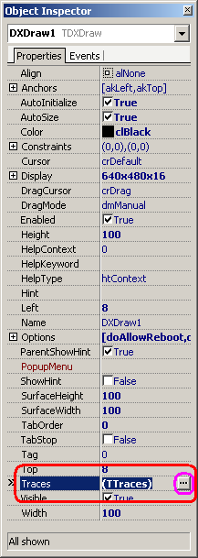 next 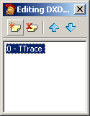 next 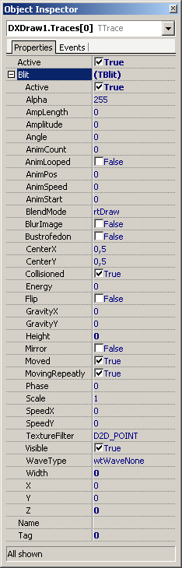
There can be set all the blit parameters directly. Please do not forget fill the name of item!

Editor is called as component editor of DXDraw like:
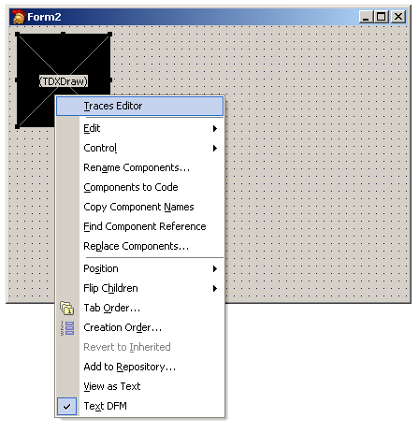

And there is main layout of editor:

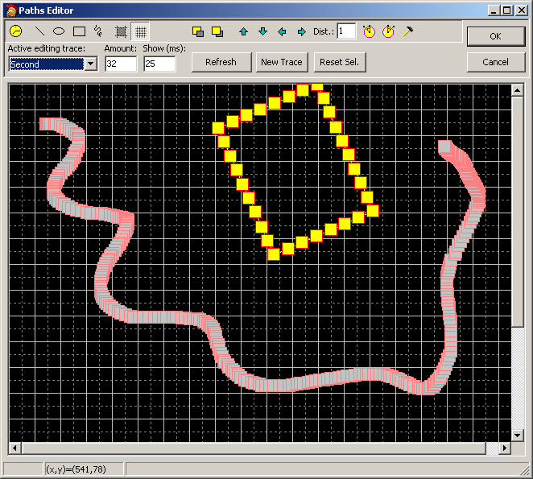

How to works

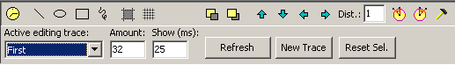

From menu you can invoke (first line, left to right):
Blit timing – set new value for active blit trace from “Show (ms)” edit box.
When is strike button for line, circle, free line or box, all trace made before are throw and new will be created.
Line – start draw line (two points needed).
Ellipse or circle – start drawing ellipse or circle (strike CTRL key), two rectangle points needed.
Box – like ellipse, two rectangle points needed.
Free line – points are catch when you move of mouse over area and left mouse button is strike.
Selection – it sign selection area only, two rectangle points needed.
Grid – can be show/hide grid for better points moving.
Send to back – move selected blit to back.
Bring to front – move selected blit to front.
Moves – four buttons for selected blit moving up, down left and right.
Distance – 1..255 values for rotate access needed.
Rotate left – selected blit is rotate left about center with Distance angle.
Rotate right – selected blit is rotate right about center with Distance angle.
Properties – now do nothing (for future use).
(The second line, from left to right)
Active editing trace – select trace for editing, active trace has yellow color and any point of trace can be moved by mouse (left button is pressed) to new place (left mouse button is released). Point is changing shape from box to circle when cursor of mouse is over.
Amount – is value for spray on line, circle or box (default value is 32). For free line is amount get dynamically.
Show – is value in miliseconds and tell to every point how long can be showed. Value for active blit can be changed by blit timing button.

Buttons
Refresh – only clear the buffer of trace points and show it clearly.
New trace – new trace can be created directly from editor
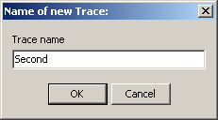
Name of new trace must be filled and has to be unique.
Values of blit can be changed in Object Inspector easy way with set all events when it is needed.
Reset sel. – reset actual selection area, no more.
Cancel – discard changes and close the editor
OK – accept changes, create or refresh objects and return back to DXDraw object all new traces.

Trace is designed and attached image from each path (can be common too)

For item create event handler like:

Image will be attached into blit. Sender is TBlit type always.

procedure TForm1.DXDrawTraces0GetImage(Sender: TObject);
begin
TBlit(Sender).Image := DXImageList.Items[0];
end;

When you won’t use path, you can link blit to your code like mouse – similar as cursor:

procedure TForm1.DXDrawTraces0Move(Sender: TObject; LagCount: Integer;
var MoveIt: Boolean);
begin
TBlit(Sender).X := mX;
TBlit(Sender).Y := mY;
end;

Note: When you want change cursor to own, please turn of implicit cursor, example in OnCreate of form, like ShowCursor(False).

How create code in main loop in DXTimer

//Update DXInputcomponent so we can receive new input
DXInput1.Update;

DXDraw1.BeginScene;
DXDraw1.Render; //that’s all
DXDraw1.EndScene;
//Flip the buffers so the player can actually see what's happening
DXDraw1.Flip;

Midi store editor

Music in midi format can be store into resource and directly play from memory. I want do similar functionality like DXSound for wave store. But for music is midi better because smaller than wave. Sorry, it is not editor for editing midi sample but load/save functionality to resources with playing for hearing only.

How load all wanted midis?

Right mouse button click on component and select from menu Open… item.
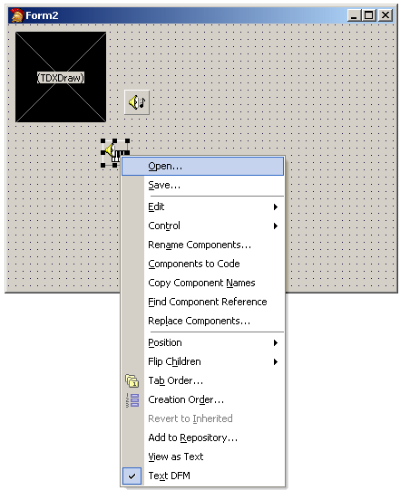
Next select one or more midi files in standard dialog (file type need select to *.mid)
All selected files will be store to resource under own filenames like:
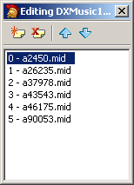 and select midi ellipsis in Object Inspector 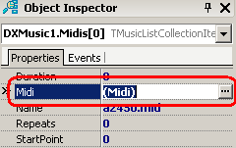

Now you can play music from panel like wave play panel (and save or load item if you want)

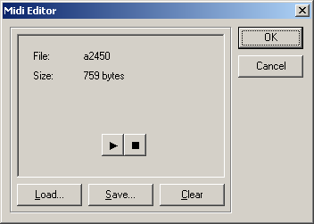

DIB effect editor

Effect editor is simple editor for creating shine spot effect and add it directly into DXImageList as item on fly.

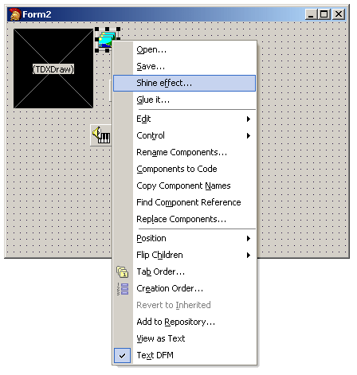
Sorry for name, I think that as shine effect it will be better.

Main editor panel (two variant of image):
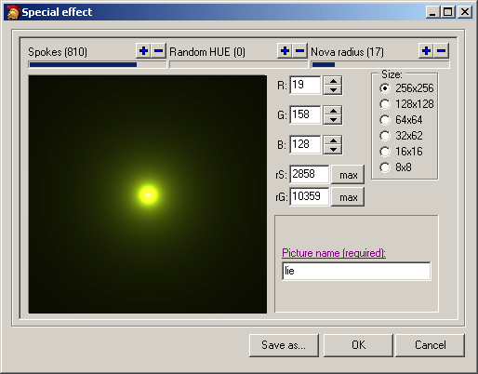

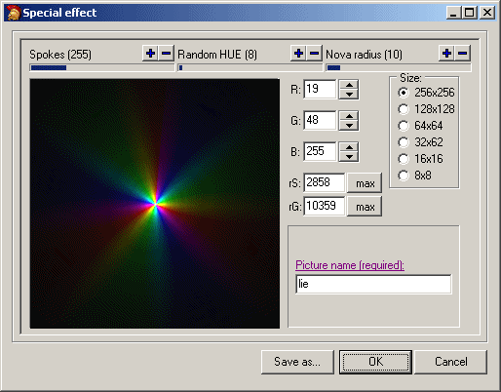

User can set up spokes, hue and radius (by mouse, drags the progress bar, or +/- button). Initial color value is R, G, B and limits rS (random spoke) and rG (random gauss). Image size can be up to 256x256 px. Name of image is required (will be used for identification of texture in texture buffer).

Glue-it editor

Glue-it editor is more complicated property editor than effect editor. It does allow make one image from many images, restructure to maximum texture size, change transparent color, join transparent channel or generate mask and more.

Editor has three parts:
1/ Glue-It panel
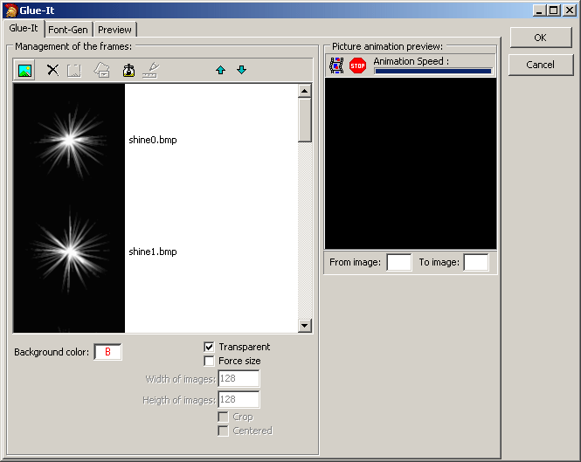

Part named management of the frames does allow open sequence of image, show opened images in list and move up/down or erase selected.
Initial value for background is white color and transparent is turn on (background will be filled white). Check box named force size is used for normalize of images no the same size. Force size can be set to boxes as width and height. When is wrote sizes smaller, image can be crops (else will be shrink). And when is wrote sizes bigger, image can be centered when you want.

Buttons

Add – images will be opened and added to list.
Clear – remove all images from list.
Remove – selected image will be erase from list.
Save – save glued image to file.
Glue it –glue images into one image (can be show in preview).
Scaled – is not used now.
Up – selected image go up and selection will be lost.
Down – selected image go down and selection will be lost.

Part for picture animation preview does allow show sequence images in preview window (image can be moved by mouse)

Start – Image will be animated
Stop – Animation stopts
Speed – Speed of animation, can be set up by mouse drag progress bar.
From image/To image – boxes for set first and last frame of animation (values are filled after glue-it).

2/ Font panel
Special feature does allow generate font for using via DXFont.
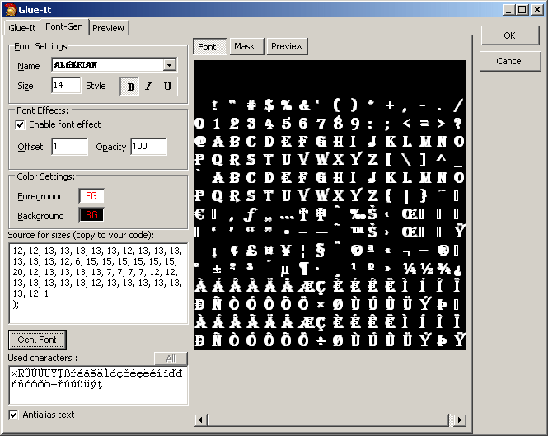
Font and its properties can be simple setting and can be use font effect (shadow) and color.
You can copy to source code fragment constant of sizes each character.
Main button (Gen.Font) will generate image (it is similar of glue-it function). You can see font and mask (in final is create DIB32 contain image with alphachannel.
Small preview for write own text like
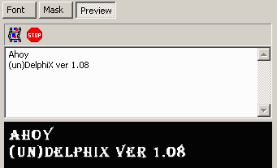
All image of font is showed in preview on next page.

3/ Image editor in preview
Image editor is very trivial tool and it does allow show result of glue-it operation (but other images from file)
There can be manually get/fill transparent color (as helper is there small zoom window right bottom of panel), restructure of images (in mode resize or replace) or use some simple DIB effect with duration value (so set up by mouse too).
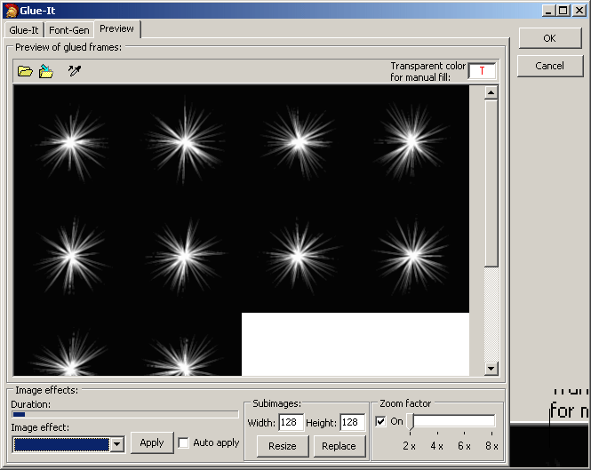
When you press OK button, image will be store into image list.

Sprite editor

Sprite editor contain access for default value for each type of sprite used in (un)DelphiX. For special type of sprite – TBackgroundSprite does allow make maps directly like as property editor.

Why it is done?

I want create fully static sprite with access to all items of main container (form or dxdraw) and store all properties to resources of form. And last I want a less programming code (when Delphi knows how does wrapper around events, let do it!).

How to use?
At first, place on form DXSpriteEngine component and set property like:
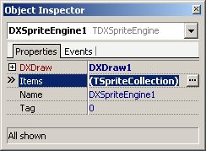 add any items into 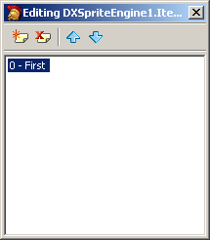

And next set property of first sprite

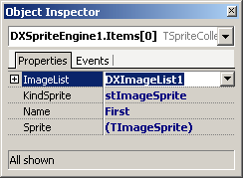 set up main events too 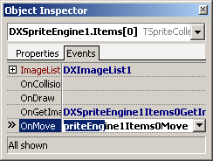

And Delphi will be generating code like:

procedure TForm2.DXSpriteEngine1Items0GetImage(Sender: TObject;
var Image: TPictureCollectionItem);
begin
//you write link to own image
Image := DXImageList1.Items.Find('lie0');
end;
procedure TForm2.DXSpriteEngine1Items0Move(Sender: TObject;
var MoveCount: Integer);
begin
//access to your mouse handler – from dxdraw OnMouse event
with Sender as TImageSprite do begin
X := MouseX;
Y := MouseY;
end;
end;

And first block of work is done. Now must be set some properties of sprite:
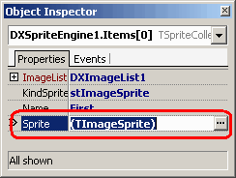 Press ellipsis button for sprite editor invoke

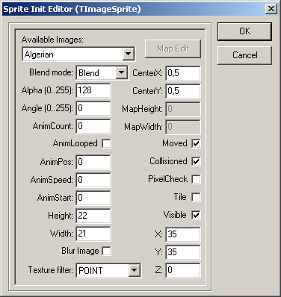

There can be set up all properties and store into resource. There can be managing the sprite animation, blending/shining/darking or other (rotation, blurring or texture filtering).

Examples

1a/ Initialize image of sprite

procedure TForm1.DXSpriteEngine1Items0GetImage(Sender: TObject;
var Image: TPictureCollectionItem);
begin
{initialize image is indispensable}
{other way is TForm.OnCreate}
Image := DXImageList1.Items.Find('SpriteToRight')
end;

1b/ Move event

procedure TForm1.DXSpriteEngine1Items0Move(Sender: TObject;
var MoveCount: Integer);
begin
{can be searched in multi move event}
{or selected from a sender}
with Sender as TImageSpriteEx do begin
if isUp in DXInput1.States then
Y := Y - 10;
if isDown in DXInput1.States then
Y := Y + 10;
if isLeft in Form1.DXInput1.States then
begin
if Image = DXImageList1.Items.Find('SpriteToRight') then
Image := DXImageList1.Items.Find('SpriteToLeft');
Width := Image.Width;
Height := Image.Height;
X := X - 10; //move left
end;
if isRight in Form1.DXInput1.States then
begin
if Image = DXImageList1.Items.Find('BeeLeft') then
Image := DXImageList1.Items.Find('BeeRight');
Width := Image.Width;
Height := Image.Height;
X := X + 10; //move right
end;
{reanimate() is move animation procedure from TImageSprite}
{other way have to rewrite here youself}
Reanimate(MoveCount) //indispensable
end;
end;

2 a / How create multiple sprite

procedure TForm1.FormCreate(Sender: TObject);
var
i: Integer;
begin
//Create 50 sprites here
//MyEnemySprite - sprite have to exist and has all events
for i := 1 to 50 do
begin
with DXSpriteEngine1.Items.Add do begin
KindSprite := stImageSprite;
Sprite.AsSign(DXSpriteEngine1.Items.Find('MyEnemySprite').Sprite);
Sprite.X := Random(DXDraw1.SurfaceWidth); //Set the Position Randomly
Sprite.Y := Random(DXDraw1.SurfaceHeight);
Name := Format('EnemySprite%d', [I]); //simple name for sprite
Sprite.Tag := 0; //for sprite you can use Tag property as well
end;
end;
end;

Note: Under Delphi 2005 does not work properly function use with-do sequence for fly-object-create – instance of object is in with-do lost! Please use local variable for safely store object instance.

Or you can use clone mechanism for create multiple sprite like

procedure TForm1.FormCreate(Sender: TObject);
var
i: Integer;
begin
//Create 50 sprites here
//MyEnemySprite - sprite have to exist and has all events
for i := 1 to 50 do
begin
with DXSpriteEngine1.Items.Find('MyEnemySprite').Clone(Format('EnemySprite%d', [i])) do
begin
X := Random(DXDraw1.SurfaceWidth); //Set the Position Randomly
Y := Random(DXDraw1.SurfaceHeight);
Tag := i; //for sprite you can use Tag property as well
end;
end;
end;

2 b / How detect collision

procedure TForm1.DXSpriteEngine1Items0Collision(Sender: TObject;
var Done: Boolean);
begin
//MySprite exists too once
//For collision have to different sprite
if Sender <> DXSpriteEngine1.Items.Find('MySprite') then
with (Sender as TImageSprite) do
begin
// Static sprite cannot be dead but can be hidden
//Dead; //Kill or hide MyEnemySprite here
DXWaveList1.Items.Find('TaDa').Play(False); //Tada
end;
end;

2 c / Own sprite movement (no prefix of form needed)

procedure TForm1.DXSpriteEngine1Items0Move(Sender: TObject;
var MoveCount: Integer);
begin
//movement
with Sender as TImageSprite do begin
if isUp in DXInput1.States then
Y := Y - 15;
if isDown in DXInput1.States then
Y := Y + 15;
if isLeft in DXInput1.States then
X := X - 15;
if isRight in DXInput1.States then
X := X + 15;
//detect limits of border
if X > DXDraw1.SurfaceWidth then X := 1;
if Y > DXDraw1.SurfaceHeight then Y := 1;
if X <= 0 then X := DXDraw1.SurfaceWidth - 1;
if Y <= 0 then Y := DXDraw1.SurfaceHeight - 1;
//execute collision through sprites
Collision;
end;
end;

2 d / Chaotic move of EnemySprites

procedure TForm1.DXSpriteEngine1Items1Move(Sender: TObject;
var MoveCount: Integer);
begin
if Sender <> DXSpriteEngine1.Items.Find('MySprite') then
with Sender as TImageSprite do
begin
//Choose a random new direction at a random time
if (Random(30) = 15) or (Tag = 0) then
Tag := Random(5);
//Do the movement
case Tag of
1: X := X + 15;
2: X := X - 15;
3: Y := Y + 15;
4: Y := Y - 15;
end;
//If we're out of the screen we want to pop up at the other side again
if X > DXDraw1.SurfaceWidth then X := 1;
if Y > DXDraw1.SurfaceHeight then Y := 1;
if X <= 0 then X := DXDraw1.SurfaceWidth - 1;
if Y <= 0 then Y := DXDraw1.SurfaceHeight - 1;
end
end;

2 d / Images initialization (can be more initialization parts)

procedure TForm1.DXSpriteEngine1Items0GetImage(Sender: TObject;
var Image: TPictureCollectionItem);
begin
Image := DXImageList1.Items.Find('MyEnemySprite');
end;
procedure TForm1.DXSpriteEngine1Items1GetImage(Sender: TObject;
var Image: TPictureCollectionItem);
begin
Image := DXImageList1.Items.Find('MySprite');
end;

3 a / Backgroudsprite initialization of all

Here is classic way for initialization of backroud sprite.
When you use new look of sprites, all initialization will be store to form and no more code need here.
procedure TForm1.FormCreate(Sender: TObject);
var
i: Integer;
begin
Blend := 128;
//Create background layer 1
with DXSpriteEngine1.Items.Find('Back').Sprite as TBackgroundSprite do begin
//Since we use only one tile we set the map to 1 x 1
SetMapSize(1, 1);
//Now we set the image
Image := DXImageList1.Items.Find('Back');
//And now the depth, this is indicated by the Z property
//The lower the number, the deeper the layer
//(this can also be used with normal TImageSprite Sprites)
Z := -2;
//We say the map has to be tiled, The image has to repeat over and over
Tile := True;
end;
//Now we create layer 2
with DXSpriteEngine1.Items.Find('Back2').Sprite as TBackgroundSprite do begin
SetMapSize(1, 1);
Image := DXImageList1.Items.Find('Back2');
Z := -5; //A lower Z number 'cos Layer 2 has to be under Layer 1
Tile := True;
end;
//Sprites front of layers
for i := 1 to 6 do
begin
//Now we create the first row of balls
with DXSpriteEngine1.Items.Add do begin
Name := Format('PlayerE%d', [I]);
KindSprite := stImageSprite;
with Sprite as TImageSprite do begin
Image := DXImageList1.Items.Find('Player');
Width := Image.Width;
Height := Image.Height;
X := 160;
Y := i * 80;
Tag := 1;
OnMove := DXSpriteEngine1Items2Move
end;
end;
//And we create the 2nd row of ships
with DXSpriteEngine1.Items.Add do begin
Name := Format('PlayerL%d', [I]);
KindSprite := stImageSprite;
with Sprite as TImageSprite do begin
Image := DXImageList1.Items.Find('Player');
Width := Image.Width;
Height := Image.Height;
X := 240;
Y := i * 80;
Tag := 1;
OnMove := DXSpriteEngine1Items2Move
end;
end;
//And the third and last row of ships
with DXSpriteEngine1.Items.Add do begin
Name := Format('PalyerR%d', [I]);
KindSprite := stImageSprite;
with Sprite as TImageSprite do begin
Image := DXImageList1.Items.Find('Player');
Width := Image.Width;
Height := Image.Height;
X := 320;
Y := i * 80;
Tag := 1;
OnMove := DXSpriteEngine1Items2Move
end;
end;
end;
end;

Next is simplified initialization part of OnCreate event of form in newest version of (un)DelphiX:
Flyer as basic sprite has set up all properties and events in design time – all will be cloned and only a few properties must be changed.

procedure TForm1.FormCreate(Sender: TObject);
var
i: Integer;
begin
//Sprites front of layers
for i := 1 to 6 do
begin
//Now we create the first row of ships
with DXSpriteEngine1.Items.Find('Flyer').Clone(Format('PlayerE%d', [I])) do
begin
X := 160;
Y := i * 80;
Tag := 1;
end;
//And we create the 2nd row of ships
with DXSpriteEngine1.Items.Find('Flyer').Clone(Format('PlayerL%d', [I])) do
begin
X := 240;
Y := i * 80;
Tag := 1;
end;
//And the third and last row of ships
with DXSpriteEngine1.Items.Find('Flyer').Clone(Format('PlayerLRd', [I])) do
begin
X := 320;
Y := i * 80;
Tag := 1;
end;
end;
//because Flyer is master sprite, must be hidden
(DXSpriteEngine1.Items.Find('Flyer').Sprite as TImageSprite).Visible := False;
HardwareSwitch := True;
end;

3 b / Move of background layers automatically

procedure TForm1.DXSpriteEngine1Items0Move(Sender: TObject;
var MoveCount: Integer);
begin
//Automatically move the 1st layer with a speed of 5 to the right
with Sender as TBackgroundSprite do
X := X + 5;
end;
procedure TForm1.DXSpriteEngine1Items1Move(Sender: TObject;
var MoveCount: Integer);
begin
//Automatically move the 2nd layer with a speed of 1 to the right
// this gives a nice parralax effect since the first layer goes faster than the second, now we get the illusion of depth...
with Sender as TBackgroundSprite do
X := X + 1;
end;

3 c / Move a cluster of sprites

procedure TForm1.DXSpriteEngine1Items2Move(Sender: TObject;
var MoveCount: Integer);
begin
//Proccess Input
with Sender as TImageSprite do begin
if isLeft in DXInput1.States then
Y := Y + 10;
if isRight in DXInput1.States then
Y := Y - 10;
if isUp in DXInput1.States then
X := X - 10;
if isDown in DXInput1.States then
X := X + 10;
end;
end;

3 d / Enhancement drawing – blending

For background sprites can be set up this property directly for each chip. But when is wanted any special drawing like overlapping that can be write here. For drawing can be used specialized encapsulate function from DXDraw unit.

procedure TForm1.DXSpriteEngine1Items1Draw(Sender: TObject);
begin
{enhacement for drawing tile, can be use blend or other techniques}
{for drawing different to Draw() have to set HW turn on for better speed}
with TBackgroundSprite(Sender) do
{there can be use DrawAlpha, DrawAdd or DrawSub }
Image.DrawAlpha(DXDraw1.Surface, ChipsRect, ChipsPatternIndex, Blend);
end;

How create code in main loop in DXTimer
DXDraw1.BeginScene;
DXDraw1.Surface.Fill(0);
//Update DXInputcomponent so we can receive new input
DXInput1.Update;
//Now move the sprites, this method will execute the DoMove method of all it's sprites
DXSpriteEngine1.Move(1);
//Draw the sprites on the screen
DXSpriteEngine1.Draw;
DXDraw1.EndScene;
//Flip the buffers so the player can actually see what's happening
DXDraw1.Flip;

Background sprite map editor

Editor is used for create map based on structured image from DXImageList. It is part of sprite editor but only for TBackgroundSprite class.

User click to map edit button. Default values are set up as shown here:

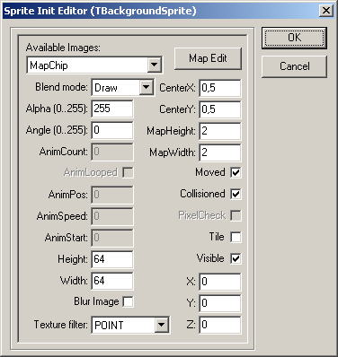
For set order can be change Z value depend other layers.
Image must be attached before create the map layout.

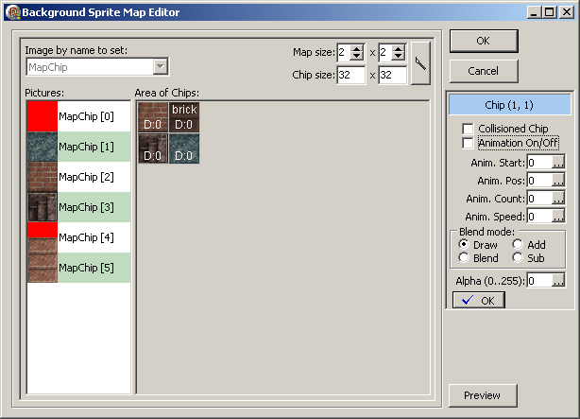

Object must be linked to image (compact=one image or segmented=more images). Layer map can be dynamically set to size (minimum size is 1x1 chips). Sub-pictures from attached image can be drag and drop from list to chip of map or chip to chip. When chip is marked as collisioned, text “brick” is shown on chip (and motion is darkness). Initial value of chip is 32x32 px (but can be any size and non squared too).

Double click to any chip shows right panel for detailed change each chip of map. Main feature is above all draw mode or collision flag. Click to OK button will be right panel hidden and accepted data write into buffer.

Layer can be resized without data lost (when is area make smaller, data are loss always). Chip size is depend by sub-image size, must be the same.

Default values for each chip are copied from owner object (see main sprite panel).

